

Federal Emergency management agency

National flood insurance program

Elevation certificate

and

instructions

NATIONAL FLOOD INSURANCE PROGRAM
ELEVATION CERTIFICATE

PAPERWORK BURDEN DISCLOSURE NOTICE

FEMA Form 81-31

The public reporting burden for this form is estimated to be 3.0 hours per response. The burden estimate includes the time for reviewing instructions, searching existing data sources, gathering and maintaining the needed data, and completing, reviewing, and submitting the form. You are not required to respond to this collection of information unless a valid OMB control number appears in the upper right corner of this form. Send comments regarding the accuracy of the burden estimate and any suggestions for reducing this burden to: Information Collections Management, Federal Emergency Management Agency, 500 C Street, SW, Washington, DC 20472, Paperwork Reduction Project (3067-0077). NOTE: Please do not send your completed form to the above address.

PURPOSE OF THE ELEVATION CERTIFICATE

The Elevation Certificate is an important administrative tool of the National Flood Insurance Program (NFIP). It is to be used to provide elevation information necessary to ensure compliance with community floodplain management ordinances, to determine the proper insurance premium rate, and to support a request for a Letter of Map Amendment or Revision (LOMA or LOMR-F).

The Elevation Certificate is required in order to properly rate post-FIRM buildings, which are buildings constructed after publication of the Flood Insurance Rate Map (FIRM), for flood insurance Zones A1-A30, AE, AH, A (with BFE), VE, V1-V30, V (with BFE), AR, AR/A, AR/AE, AR/A1-A30, AR/AH, and AR/AO. The Elevation Certificate is not required for pre-FIRM buildings unless the building is being rated under the optional post-FIRM flood insurance rules.

As part of the agreement for making flood insurance available in a community, the NFIP requires the community to adopt a floodplain management ordinance that specifies minimum requirements for reducing flood losses. One such requirement is for the community to obtain the elevation of the lowest floor (including basement) of all new and substantially improved buildings and maintain a record of such information. The Elevation Certificate provides a way for a community to comply with this requirement.

Use of this certificate does not provide a waiver of the flood insurance purchase requirement. Only a LOMA or LOMR-F from the Federal Emergency Management Agency (FEMA) can amend the FIRM and remove the Federal mandate for a lending institution to require the purchase of flood insurance. However, the lending institution has the option of requiring flood insurance even if a LOMA/LOMR-F has been issued by FEMA. The Elevation Certificate may be used to support a LOMA or LOMR-F request. Lowest floor and lowest adjacent grade elevations certified by a surveyor or engineer will be required if the certificate is used to support a LOMA or LOMR-F request.

This certificate is used only to certify building elevations. A separate certificate is required for floodproofing. Under the NFIP, non-residential buildings can be floodproofed up to or above the Base Flood Elevation (BFE). A floodproofed building is a building that has been designed and constructed to be watertight (substantially impermeable to floodwaters) below the BFE. Floodproofing of residential buildings is not permitted under the NFIP unless FEMA has granted the community an exception for residential floodproofed basements. The community must adopt standards for design and construction of floodproofed basements before FEMA will grant a basement exception. For both floodproofed non-residential buildings and residential floodproofed basements in communities that have been granted an exception by FEMA, a floodproofing certificate is required.

INSTRUCTIONS FOR COMPLETING THE ELEVATION CERTIFICATE

The Elevation Certificate is to be completed by a land surveyor, engineer, or architect who is authorized by law to certify elevation information when elevation information is required for Zones A1-A30, AE, AH, A (with BFE), VE, V1-V30, V (with BFE), AR, AR/A, AR/AE, AR/A1-A30, AR/AH, or AR/AO. Community officials who are authorized by law or ordinance to provide floodplain management information may also complete this form. For Zones AO and A (without BFE), a community official, a property owner, or an owner’s representative may provide information on this certificate, unless the elevations are intended for use in supporting a LOMA or LOMR-F. Certified elevations must be included if the purpose of completing the Elevation Certificate is to obtain a LOMA or LOMR-F.

In Puerto Rico only, elevations for building information and flood hazard information may be entered in meters.

SECTION A - Property owner Information

This section identifies the building, its location, and its owner. Enter the name(s) of the building owner(s), the building’s complete street address, and the lot and block number. If the building’s address is different from the owner’s address, enter the address of the building being certified. If the address is a rural route or a Post Office box number, enter the lot and block numbers, the tax parcel number, the legal description, or an abbreviated location description based on distance and direction from a fixed point of reference. For the purposes of this certificate, “building” means both a building and a manufactured (mobile) home.

A map may be attached to this certificate to show the location of the building on the property. A tax map, FIRM, or detailed community map is appropriate. If no map is available, provide a sketch of the property location, and the location of the building on the property. Include appropriate landmarks such as nearby roads, intersections, and bodies of water. For building use, indicate whether the building is residential, non-residential, an addition to an existing residential or non-residential building, an accessory building (e.g., garage), or other type of structure. Use the Comments area of Section F if needed.

If latitude and longitude data are available, enter them in degrees, minutes, and seconds, or in decimal degrees, taken at the center of the front of the building. Enter arc seconds to two decimal places. Indicate the horizontal datum and the source of the measurement data (for example, taken with GPS, scaled from a USGS Quad Map, etc.).

SECTION B - FLOOD INSURANCE RATE MAP (FIRM) INFORMATION

Complete the Elevation Certificate on the basis of the FIRM in effect at the time of the certification.

The information for Section B is obtained by reviewing the FIRM panel that includes the building’s location. Information about the current FIRM and a pamphlet titled “Guide to Flood Maps” are available from the Federal Emergency Management Agency (FEMA) website at http://www.fema.gov or by calling 1-800-427-4661. If a Letter of Map Amendment (LOMA) or Letter of Map Revision (LOMR-F) has been issued by FEMA, please provide the letter date and case number in the Comments area of Section D or Section G, as appropriate.

Item B1. NFIP Community Name & Community Number. Enter the complete name of the community in which the building is located and the associated 6-digit community number. For a building that is in an area that has been annexed by one community but is shown on another community’s FIRM, enter the community name and 6-digit number of the annexing community. For a newly incorporated community, use the name and 6-digit number of the new community. Under the NFIP, a “community” is any State or area or political subdivision thereof, or any Indian tribe or authorized native organization, that has authority to adopt and enforce floodplain management regulations for the areas within its jurisdiction. To determine the current community number, see the NFIP Community Status Book, available on FEMA’s website at http://www.fema.gov or by calling 1-800-427-4661.

Item B2. County Name. Enter the name of the county or counties in which the community is located. For an unincorporated area of a county, enter “unincorporated area.” For an independent city, enter “independent city.”

Item B3. State. Enter the 2-letter state abbreviation (for example, VA, TX, CA).

Item B4. Map and Panel Number. Enter the 10-digit number shown on the FIRM panel where the building or manufactured (mobile) home is located. The first six digits will not match the NFIP community number: 1) when the sixth digit is a “C,” in which case the FIRM panel is in a countywide format; or 2) when one community has annexed land from another community but the FIRM panel has not been updated to reflect this annexation. If the sixth digit is a “C,” it is followed by a four-digit map number. For maps not in countywide format, enter the “community panel number” shown on the FIRM.

Item B5. Suffix. Enter the suffix letter shown on the FIRM panel that includes the building’s location.

Item B6. FIRM Index Date. Enter the effective date or map revised date shown on the FIRM Index.

Item B7. FIRM Panel Effective/Revised Date. Enter the map effective date or the map revised date shown on the FIRM panel. This will be the latest of all dates shown on the map. The current FIRM panel effective date can be determined by calling 1-800-427-4661.

Item B8. Flood Zone(s). Enter the flood zone, or flood zones, in which the building is located. All flood zones containing the letter “A” or “V” are considered Special Flood Hazard Areas. The flood zones are A, AE, A1-A30, V, VE, V1-V30, AH, AO, AR, AR/A, AR/AE, AR/A1-A30, AR/AH, and AR/AO. Each flood zone is defined in the legend of the FIRM panel on which it appears.

Item B9. Base Flood Elevation(s). Using the appropriate Flood Insurance Study (FIS) Profile, Flood Elevation Table, or FIRM panel, locate the property and enter the BFE (or base flood depth) of the building site. If the building is located in more than one flood zone in Item B8., list all appropriate BFEs in Item B9. BFEs are shown on a FIRM or FIS Profile for Zones A1-A30, AE, AH, V1-V30, VE, AR, AR/A, AR/AE, AR/A1-A30, AR/AH, and AR/AO; flood depth numbers are shown for Zone AO. Use the AR BFE if the building is located in any of Zones AR/A, AR/AE, AR/A1-A30, AR/AH, or AR/AO. In A or V zones where BFEs are not provided on the FIRM, the community may have established BFEs or obtained BFE data from other sources. For subdivisions and other developments of more than 50 lots or 5 acres, establishment of BFEs is required by the community’s floodplain management ordinance. If the BFE is obtained from another source, enter the BFE in Item B9.

Item B10. Indicate the source of the BFE that you entered in Item B9.

Item B11. Indicate the elevation datum to which the elevations on the applicable FIRM are referenced.

Item B12. Indicate whether the building is located in a Coastal Barrier Resources System (CBRS) area or Otherwise Protected Area (OPA). Federal flood insurance is prohibited in designated CBRS areas for buildings or manufactured (mobile) homes built or substantially improved after the date of the CBRS designation. An information sheet explaining CBRS areas may be obtained on FEMA’s website at http://www.fema.gov or by calling 1-800-427-4661.

SECTION C - BUILDING ELEVATION INFORMATION (SURVEY REQUIRED)

Complete Section C if the building is located in any of Zones A1-A30, AE, AH, A (with BFE), VE, V1-V30, V (with BFE), AR, AR/A, AR/AE, AR/A1-A30, AR/AH, or AR/AO, or if this certificate is being used to support a LOMA or LOMR-F. If the building is located in Zone AO or Zone A (without BFE), complete Section E instead. To ensure that all required elevations are obtained, it may be necessary to enter the building (for instance, if the building has a basement or sunken living room, split-level construction, or machinery and equipment).

Surveyors may not be able to gain access to some crawl spaces to shoot the elevation of the crawl space floor. If access to the crawl space cannot be gained, use the following guidance:
- Use a yardstick or tape measure to measure the floor height to the “next higher floor,” and then subtract the crawl space height from the elevation of the “next higher floor.”
- Contact the local floodplain administrator of the community that the building is located in. The community may have documentation of the elevation of the crawl space floor as part of the permit issued for the building.
- If the property owner has documentation or knows the height of the crawl space floor to the next higher floor, try to verify this by looking inside the crawl space through any openings or vents.
In all three cases, provide the elevation in the Comments area and a brief description of how the elevation was obtained.

Item C1. Indicate whether the elevations to be entered in this section are based on construction drawings, a building under construction, or finished construction. For either of the first two choices, a post-construction Elevation Certificate will be required when construction is complete. If the building is under construction, include only those elevations that can be surveyed in Items C3.a-g. Use the Comments area to provide elevations obtained from the construction plans or drawings. Select “finished construction” only when all machinery and/or equipment—furnaces, hot water heaters, heat pumps, air conditioners, and elevators and their associated equipment—have been installed and the grading around the building is completed.

Item C2. Select the diagram on pages 6 and 7 that best represents the building. Then enter the diagram number and use the diagram to identify and determine the appropriate elevations requested in Items C3.a-g. If you are unsure of the correct diagram, select the diagram that most closely resembles the building being certified, or provide a sketch or photograph of the building and enter all elevations in Items C3.a-g.

Item C3. Indicate whether the elevation reference mark (benchmark) used during the field survey is an elevation mark on the FIRM. If it is not, indicate the source and datum for the elevation. Vertical control benchmarks other than those shown on the FIRM are acceptable for elevation determinations. Show the conversion from the field survey datum used to the datum used for the BFE(s) entered in Item B9. All elevations for the certificate must be referenced to the datum on which the BFE is based. Show the datum conversion, if applicable, in this section or in the Comments area of Section D. For property experiencing ground subsidence, the most recently adjusted reference mark elevations must be used for determining building elevations. However, when subsidence is involved, the BFE should not be adjusted. Enter elevations in Items C3.a-g to the nearest tenth of a foot (nearest tenth of a meter, in Puerto Rico).

Items C3.a-d. Enter the building elevations (excluding the attached garage) indicated by the selected building diagram (Item C2.) in Items C3.a-c. If there is an attached garage, enter the elevation for top of attached garage slab in Item C3.d. (Because elevation for top of attached garage slab is self-explanatory, attached garages are not illustrated in the diagrams.) If the building is located in a V zone on the FIRM, complete Item C3.c. If the flood zone cannot be determined, enter elevations for all of Items C3.a-g. For buildings in A zones, elevations a, b, d, and e should be measured at the top of the floor. For buildings in V zones, elevation c must be measured at the bottom of the lowest horizontal structural member of the floor (see drawing below). For buildings elevated on a crawl space, Diagram 8, enter the elevation of the top of the crawl space floor in Item C3.a, whether or not the crawl space has openings (flood vents). If any item does not apply to the building, enter “N/A” for not applicable.
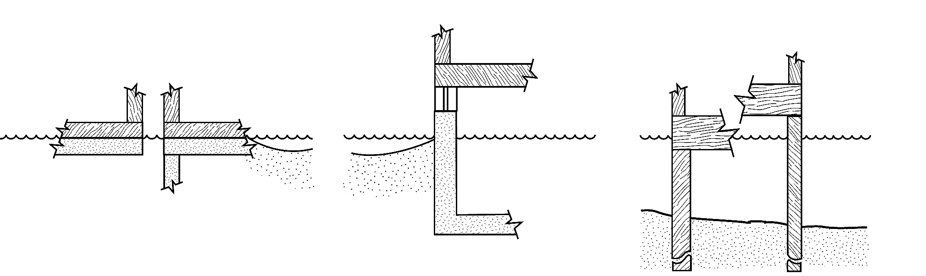
a
a
a
A ZONES
A ZONES
A ZONES
V ZONES
V ZONES
BUILDING ON
SLAB
BUILDING ON PILES,
PIERS, OR COLUMNS
BUILDING WITH
BASEMENT

c
c
ADJACENT
GRADE
BASE FLOOD
ELEVATION
ADJACENT
GRADE
BASE FLOOD
ELEVATION
Item C3.e. Enter the lowest elevation of machinery and/or equipment—furnaces, hot water heaters, heat pumps, air conditioners, and elevators and their associated equipment—in an attached garage or enclosure or on an open utility platform that provides utility services for the building. If the machinery and/or equipment is mounted to a wall, pile, etc., enter the platform elevation of the machinery and/or equipment. Indicate machinery/equipment type in the Comments area of Section D or Section G, as appropriate. If this item does not apply to the building, enter “N/A” for not applicable.

Items C3.f-g. Adjacent grade is defined as the elevation of the ground, sidewalk, patio slab, or deck support immediately next to the building. If the certificate is to be used for a LOMA or LOMR-F, provide in the Comments area the lowest adjacent grade elevation measured at the deck support or stairs if that elevation is lower than the building's lowest adjacent grade. For Zone AO, use the natural grade elevation, if available. This measurement must be to the nearest tenth of a foot (nearest tenth of a meter, in Puerto Rico) if this certificate is being used to support a request for a LOMA or LOMR-F.

Items C3.h-i. Enter the number of permanent openings (flood vents) in the walls supporting the building, including the attached garage, that are no higher than 1.0 foot above the adjacent grade. Determine the total area of all such openings in square inches (square cm, in Puerto Rico), and enter the total in Item C3.i. If the building has no permanent openings (flood vents) within 1.0 foot above adjacent grade, enter “0” (zero) for each of Items C3.h and C3.i. Enter in the Comments area whether the openings are on the foundation walls of the building and/or on the walls of the garage.

SECTION D - SURVEYOR, ENGINEER, OR ARCHITECT CERTIFICATION

Complete as indicated. This section of the Elevation Certificate may be signed by only a land surveyor, engineer, or architect who is authorized by law to certify elevation information. Place embossed seal and signature in the box next to elevations in Section C. A flat stamp is acceptable only in states that do not authorize use of an embossed seal over the signature of a professional. You are certifying that the information in Sections A, B, and C on this certificate represents your best efforts to interpret the data available and that you understand that any false statement may be punishable by fine or imprisonment under 18 U.S. Code, Section 1001. Use the Comments area of Section D, on the back of the certificate, to provide datum, elevation, or other relevant information not specified on the front.

SECTION E - BUILDING ELEVATION INFORMATION (SURVEY NOT REQUIRED) FOR ZONE AO

& ZONE A (WITHOUT BFE)

Complete Section E if the building is located in Zone AO or Zone A (without BFE). Otherwise, complete Section C instead.

Item E1. Select the diagram on pages 6 and 7 that best represents the building; then enter the diagram number. If you are unsure of the correct diagram, select the diagram that most closely resembles the building, or provide a sketch or photograph. Explain in the Comments area if the measurement provided under Item E.2, E.3, or E.4 is based on the “natural grade.”

Item E2. Enter the height in feet and inches (meters and centimeters, in Puerto Rico) of the top of the bottom floor (as indicated in the applicable diagram) above or below the highest adjacent grade (HAG). For post-FIRM buildings in Zone AO, the community’s floodplain management ordinance requires that this value equal or exceed the base flood depth on the FIRM. Buildings in Zone A (without BFE) may qualify for a lower insurance rate if an engineered BFE is developed at the site.

Item E3. For Building Diagrams 6-8 with proper openings (see page 7), enter the height in feet and inches (meters and centimeters, in Puerto Rico) of the next higher floor or elevated floor (as indicated in the applicable diagram) above the highest adjacent grade (HAG). Be sure that you have completed Items C3.h and C3.i on the front of the form to show the number of permanent openings (flood vents) within 1 foot above adjacent grade and the total area of the openings.

Item E4. Enter the height in feet and inches, in relation to the highest adjacent grade next to the building, of the platform that supports the machinery and/or equipment servicing the building. Indicate machinery/equipment type in the Comments area of Section E. If this item does not apply to the building, enter “N/A” for not applicable.

Item E5. For those communities where this base flood depth is not available, the community will need to determine whether the top of the bottom floor is elevated in accordance with the community’s floodplain management ordinance.

SECTION F - PROPERTY OWNER (OR OWNER’S REPRESENTATIVE) CERTIFICATION

Complete as indicated. This section is provided for certification of measurements taken by a property owner or property owner’s representative when responding to Sections A, B, C (Items C3.h and C3.i only), and E. The address entered in this section must be the actual mailing address of the property owner or property owner’s representative who provided the information on the certificate.

SECTION G - COMMUNITY INFORMATION (OPTIONAL)

Complete as indicated. The community official who is authorized by law or ordinance to administer the community’s floodplain management ordinance can complete Sections A, B, C (or E), and G of this Elevation Certificate. If the authorized community official completes Sections C, E, or G, complete the appropriate item(s) and sign this section.

Check Item G1. if Section C is completed with elevation data from other documentation, including elevations obtained from the Community Rating System Elevation Software, that has been signed and embossed by a licensed surveyor, engineer, or architect who is authorized by law to certify elevation information. Indicate the source of the elevation data and the date obtained in the Comments area of Section G. If you are both a community official and a licensed land surveyor, engineer, or architect authorized by law to certify elevation information, and you performed the actual survey for a building in Zones A1-A30, AE, AH, A (with BFE), VE, V1-V30, V (with BFE), AR, AR/A, AR/A1-A30, AR/AE, AR/AH, or AR/AO, you must also complete Section D.

Check Item G2. if information is entered in Section E by the community for a building in Zone A (without a FEMA-issued or community-issued BFE) or Zone AO.

Check Item G3. if the information in Items G4-G9 has been completed for community floodplain management purposes to document the as-built lowest floor elevation of the building. Section C of the Elevation Certificate records the elevation of various building components but does not determine the lowest floor of the building or whether the building, as constructed, complies with the community’s floodplain management ordinance. This must be done by the community. Items G4-G9 provide a way to document these determinations.

Item G4. Permit Number. Enter the permit number or other identifier to key the Elevation Certificate to the permit issued for the building.

Item G5. Date Permit Issued. Enter the date the permit was issued for the building.

Item G6. Date Certificate of Compliance Issued. Enter the date that the Certificate of Compliance or Occupancy or similar written official documentation of as-built lowest floor elevation was issued by the community as evidence that all work authorized by the floodplain development permit has been completed in accordance with the community’s floodplain management laws or ordinances.

Item G7. New Construction or Substantial Improvement. Check the applicable box. “Substantial Improvement” means any reconstruction, rehabilitation, addition, or other improvement of a building, the cost of which equals or exceeds 50 percent of the market value of the building before the start of construction of the improvement. The term includes buildings that have incurred substantial damage, regardless of the actual repair work performed.

Item G8. As-built lowest floor elevation. Enter the elevation of the lowest floor (including basement) when the construction of the building is completed and a final inspection has been made to confirm that the building is built in accordance with the permit, the approved plans, and the community’s floodplain management laws or ordinances. Indicate the elevation datum used.

Item G9. BFE. Using the appropriate FIRM panel, FIS, or other data source, locate the property and enter the BFE (or base flood depth) of the building site. Indicate the elevation datum used.

Enter your name, title, and telephone number, and the name of the community. Sign and enter the date in the appropriate blanks.
BUILDING DIAGRAMS

The following eight diagrams illustrate various types of buildings. Compare the features of the building being certified with the features shown in the diagrams and select the diagram most applicable. Enter the diagram number in Item C2. and the elevations in Items C3.a-C3.g.
In A zones, the floor elevation is taken at the top finished surface of the floor indicated; in V zones, the floor elevation is taken at the bottom of the lowest horizontal structural member (see drawing in instructions for Section C).
a
* A floor that is below ground level (grade) on all sides is considered a basement even if the floor is used for living purposes, or as an office, garage, workshop, etc.

DIAGRAM 1
All slab-on-grade single- and multiple-floor buildings (other than split-level) and high-rise buildings, either detached or row type (e.g., townhouses); with or without attached garage.
Distinguishing Feature – The bottom floor is at or above ground level (grade) on at least one side. *

DIAGRAM 2
All single- and multiple-floor buildings with basement (other than split-level) and high-rise buildings with basement, either detached or row type (e.g., townhouses); with or without attached garage.
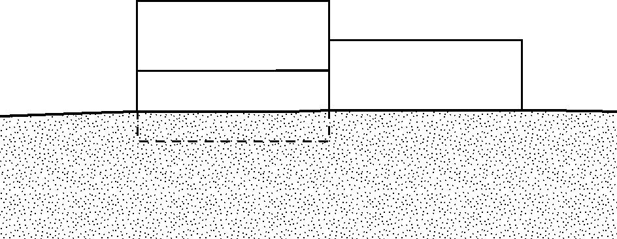
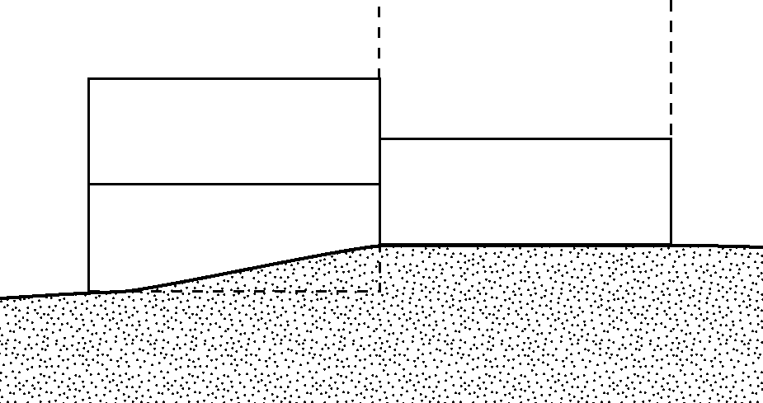
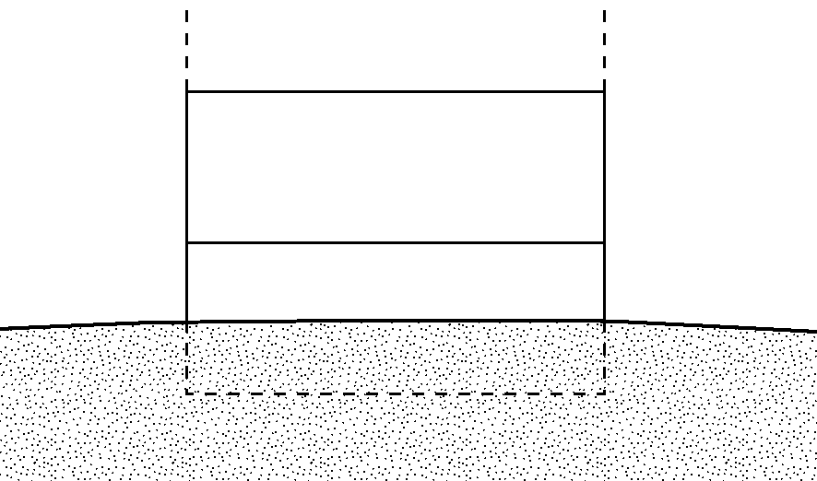
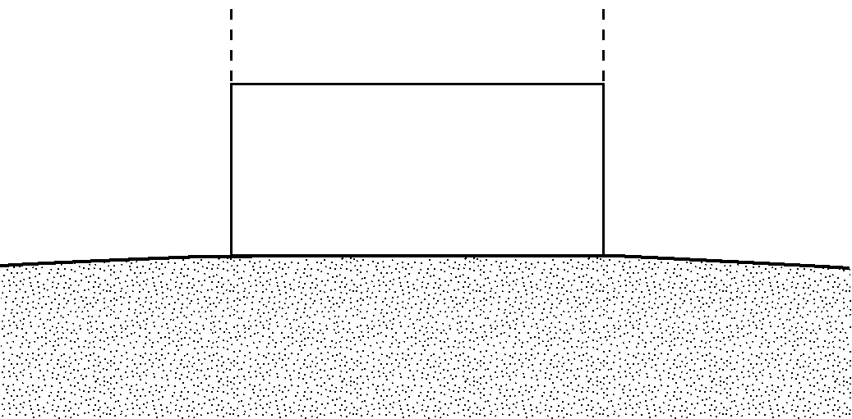
DIAGRAM 4
All split-level buildings (other than slab-on-grade), either detached or row type (e.g., townhouses); with or without attached garage.
a
b
b
b
a
NEXT HIGHER
FLOOR
BOTTOM FLOOR
b
a
GRADE
f
(determined by existing grade)
g
f
g
f
g
f
g
GRADE
GRADE
Distinguishing Feature – The bottom floor (basement or underground garage) is below ground level (grade) on all sides. Buildings constructed above crawl spaces that are below grade on all sides should also use this diagram. *
HIGHER
FLOORS
NEXT HIGHER
FLOOR

BOTTOM FLOOR
(BASEMENT)
Distinguishing Feature – The bottom floor (basement or underground garage) is below ground level (grade) on all sides. Buildings constructed above crawl spaces that are below grade on all sides should also use this diagram.*
BOTTOM FLOOR
(BASEMENT)
NEXT HIGHER
FLOOR

GRADE

DIAGRAM 3
All split-level buildings that are slab-on-grade, either detached or row type (e.g., townhouses); with or without attached garage.
Distinguishing Feature – The bottom floor (excluding garage) is at or above ground level (grade) on at least one side .*
BOTTOM
FLOOR
NEXT HIGHER
FLOOR

HIGHER
FLOORS
(determined by existing grade)
(determined by existing grade)
(determined by existing grade)

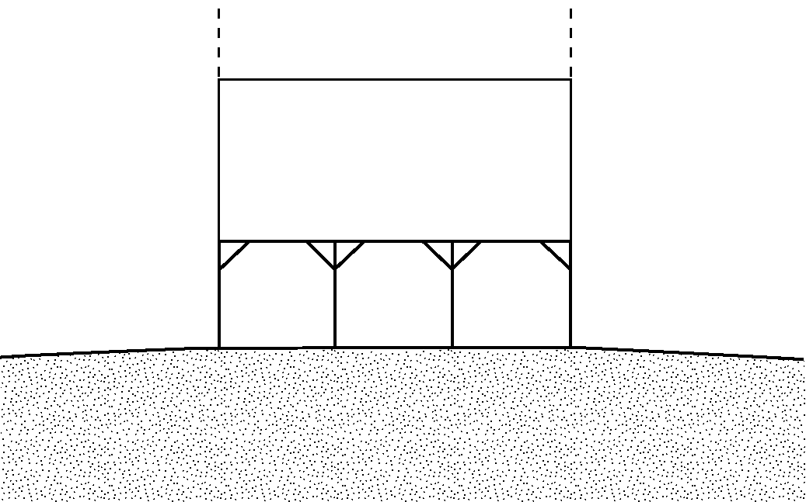
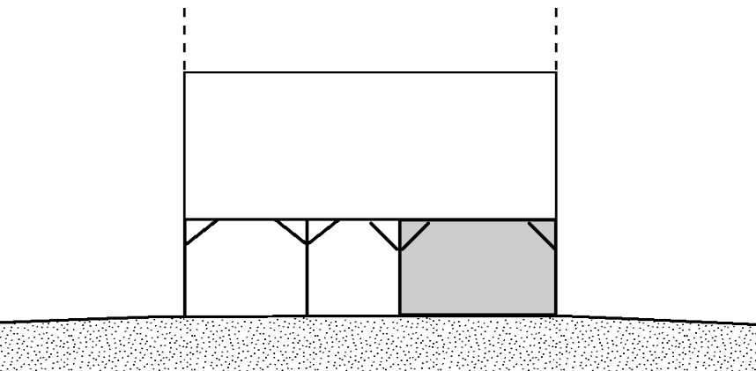
DIAGRAM 5
All buildings elevated on piers, posts, piles, columns, or parallel shear walls. No obstructions below the elevated floor.
ELEVATED
FLOOR
NEXT HIGHER
FLOOR
Distinguishing Feature – For all zones, the area below the elevated floor is open, with no obstruction to flow of flood waters (open lattice work and/or readily removable insect screening is permissible).
a
(For V zones only)
c
f
(determined by existing grade)
g
b
GRADE
DIAGRAM 6
All buildings elevated on piers, posts, piles, columns, or parallel shear walls with full or partial enclosure below the elevated floor.
c
f
(determined by existing grade)
g
Distinguishing Feature – For all zones, the area below the elevated floor is enclosed, either partially or fully. In A Zones, the partially or fully enclosed area below the elevated floor is with or without openings** present in the walls of the enclosure. Indicate information about openings in Section C, Building Elevation Information (Survey Required).
(For V zones only)
ENCLOSURE
NEXT HIGHER
FLOOR
ELEVATED
FLOOR
GRADE

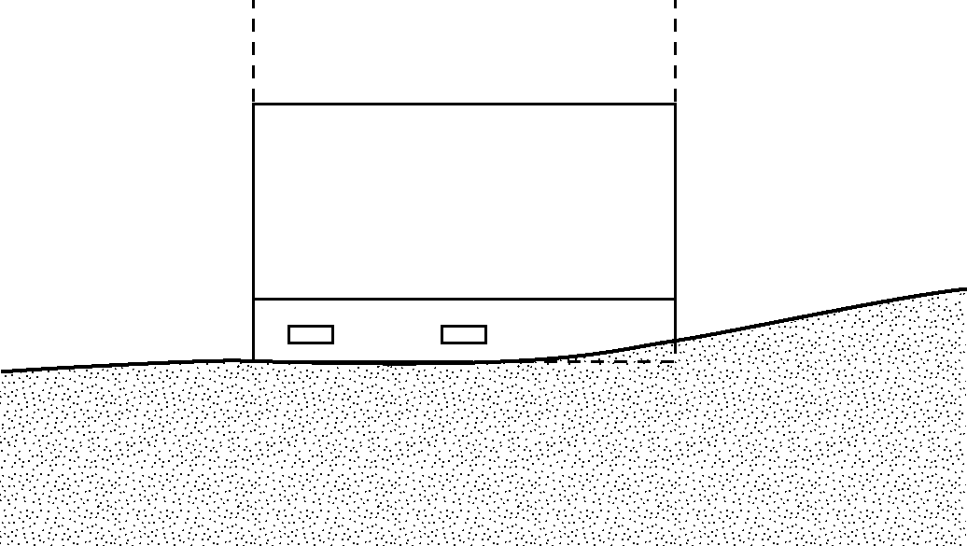
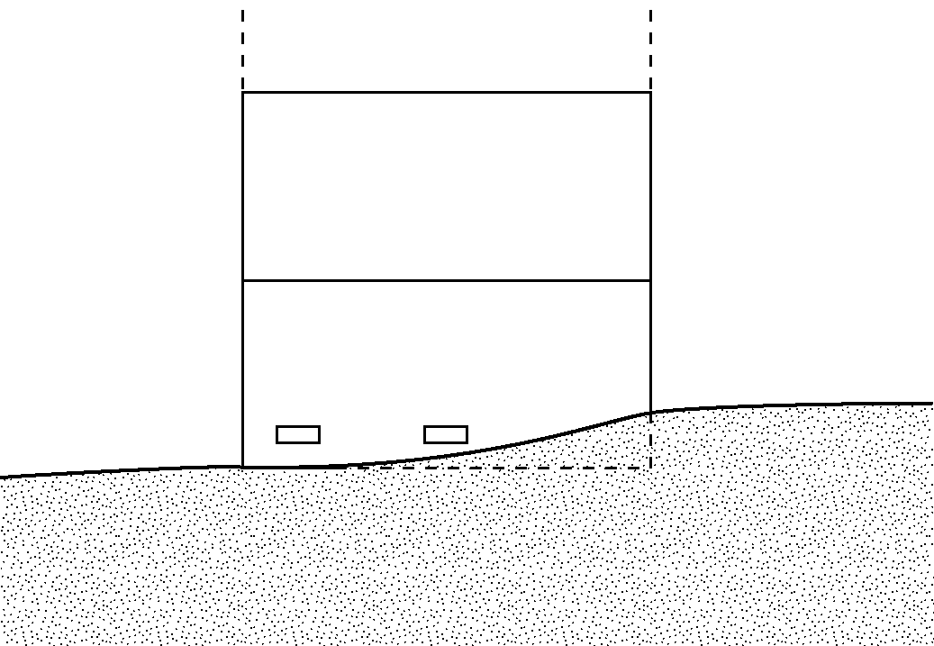
DIAGRAM 8
All buildings elevated on a crawl space with the floor of the crawl space at or above grade on at least one side, with or without an attached garage.
NEXT HIGHER
FLOOR
a
OPENINGS**

CRAWL SPACE
g
b
Distinguishing Feature – For all zones, the area below the first floor is enclosed by solid or partial perimeter walls. In all A zones, the crawl space is with or without openings** present in the walls of the crawl space. Indicate information about the openings in Section C, Building Elevation Information (Survey Required).
GRADE
DIAGRAM 7
All buildings elevated on full-story foundation walls with a partially or fully enclosed area below the elevated floor. This includes walkout levels, where at least one side is at or above grade. The principal use of this building is located in the elevated floors of the building.
NEXT HIGHER
FLOOR
b
a
f
g
WALKOUT LEVEL
Distinguishing Feature – For all zones, the area below the elevated floor is enclosed, either partially or fully. In A Zones, the partially or fully enclosed area below the elevated floor is with or without openings** present in the walls of the enclosure. Indicate information about openings in Section C, Building Elevation Information (Survey Required).
OPENINGS**

GRADE

f

** An “opening” (flood vent) is defined as a permanent opening in a wall that allows for the free passage of water automatically in both directions without human intervention. Under the NFIP, a minimum of two openings is required for enclosures or crawl spaces with a total net area of not less than one square inch for every square foot of area enclosed. Each opening must be on different sides of the enclosed area. If a building has more than one enclosed area, each area must have openings on exterior walls to allow floodwater to directly enter. The bottom of the openings must be no higher than one foot above the grade underneath the flood vents. Alternatively, you may submit a certification by a registered professional engineer or architect that the design will allow for the automatic equalization of hydrostatic flood forces on exterior walls. A window, a door, or a garage door is not considered an opening.

